
RAMAIAH
Institute of Technology
USN | 1 | M | S

(Autonomous Institute, Affiliated to VTU)
(Approved by AICTE, New Delhi & Govt. of Karnataka) Accredited by NBA & NAAC with ‘A’ Grade

MAKEUP EXAMINATIONS – FEBRUARY 2020
Program | : | B.E.: Electrical and Electronics Engineering | Semester | : | V
Course Name | : | Linear Integrated Circuits | Max. Marks | : | 100
Course Code | : | EE54 | Duration | : | 3 Hrs

Instructions to the Candidates:
- Answer one full question from each unit.

 |  | UNIT- I
1. | a) | Draw the block diagram of an operational amplifier and explain its functionality. | CO1 | (05)
 | b) | A 1V signal source with a source resistance of 68 KΩ has to be connected to a 10 KΩ load resistor. Calculate the load voltage:  i) when the load is directly connected to the source [refer fig. 1(b)(i)]  ii) when the voltage follower using 741 Op-amp is connected in between the load and the source. [refer fig. 1(b) (ii)]  (From 741 data sheet: typical open loop gain = 200000; typical open loop input impedance = 2 MΩ;  typical open loop output impedance = 75Ω)  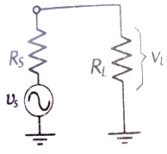  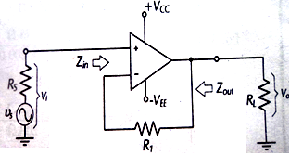  Fig. 1(b) (i) 1(b)(ii) | CO1 | (10)
 | c) | Draw the equivalent circuit of an op-amp. Also list the characteristics of an ideal op-amp. | CO1 | (05)
2. | a) | Determine the output voltage for the open loop non inverting amplifier circuit given in Fig. 2(a), if  i) V_{in(rms)} = 35.35 µV (rms value of the sine wave a.c input voltage)  ii) V_{in} = 20 mV (d.c. input)  Draw the input and output waveform for both the cases.  Op-amp used is 741 op-amp with a supply voltage of + 15V (open loop gain of op-amp is 2,00,000)  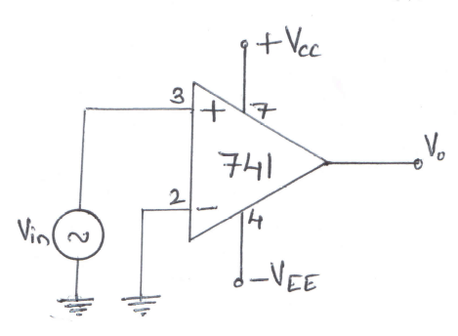  Fig. 2(a) | CO1 | (08)
 | b) | The difference of two input signals is to be amplified by a factor of 40. Each input has amplitude of approximately 40 mV. Using 741 Op-amp, design a suitable circuit such that it gives approximately equal input resistance at the two input terminal and provides output voltage nulling. Sketch the circuit with component values mentioned on the circuit. Use + 15V supply. | CO2 | (08)
 | c) | Bring out the difference between a voltage follower and an emitter follower. | CO2 | (04)
 |  | UNIT- II
3. | a) | Using a LF353 BIFET op-amp, design a high Z_{in} capacitor coupled non inverting amplifier to have a low cutoff frequency of 200 Hz. The input and output voltages are to be 15 mV respectively and the minimum load resistance is 12 KΩ. Sketch the circuit with component values mentioned on it. | CO2 | (10)
 | b) | With a neat sketch show how non saturating precision half wave rectifier can be modified to obtain two independent half-wave rectified output. Draw the waveform and explain the circuit operation. | CO2 | (06)
 | c) | What are the advantages of precision rectifier over diode rectifier? | CO2 | (04)
4. | a) | A capacitor coupled non-inverting amplifier is to have a +30V supply, a voltage gain of 50, an output amplitude of 3V, a lower cut off frequency of 50 Hz and a load resistance of 10 KΩ. Design a suitable circuit using a 741 op-amp. Draw the circuit diagram with component values mentioned on it. Also draw the input waveform, output of the op-amp waveform (usually termed as V₀|) and output of the circuit waveform (V₀) when (i) The bottom most resistor of the circuit connected to ground directly (ii) A capacitor is connected in between the bottom most resistor and ground. | CO2 | (12)
 | b) | With a neat sketch and waveform through out the circuit, explain the working of high input impedance precision full wave rectifier. Derive an expression for its output voltage. | CO2 | (08)
 |  | UNIT- III
5. | a) | - Design a wide band reject filter having f_{H}=400 Hz and f_{L}=2 KHz and a pass band gain of 4.  - Draw the frequency response plot of this filter.  - Calculate the value of Q for the filter. | CO2 | (10)
 | b) | Design a RC phase shift oscillator for an oscillating frequency of 3 kHz. Draw the circuit with component values mentioned on it. If the circuit has to oscillate for 3.3 KHz instead of 3 KHz what modification do you suggest? | CO2 | (07)
 | c) | What do you mean by frequency scaling technique? Briefly explain. | CO2 | (03)
6. | a) | With a neat circuit diagram, explain the working of triangular wave generator. Derive an expression for its frequency of oscillation. | CO2 | (06)
 | b) | A +5V, 10kHz square wave from a signal source with a resistance of 100Ω is to have its positive peak clamped precisely at ground level. Tilt on the output is not to exceed 1% of the peak amplitude of the wave. Design a suitable op-amp circuit using a supply of +12V.Draw the circuit diagram with component values mentioned on it. | CO2 | (10)
 | c) | With a neat sketch explain the working of a dead zone circuit. | CO2 | (04)
 |  | UNIT- IV
7. | a) | With a neat sketch and waveforms demonstrate the effect of noise on an open loop zero crossing detector. Suggest the method to reduce the impact of noise on the output voltage of ZCD. | CO3 | (10)
 | b) | Using a 709 Op-amp, design an inverting amplifier as shown in Fig.7(b) to have A_{V}=1000 and V_{s}=5mV (I_{B(max)} for 709=200nA) and also, calculate the input stray capacitance that might make the circuit unstable, when:  i) The signal source is open circuited.  ii) R₃ is short circuited  iii) R₃ is present and all resistors are reduced by a factor of 5.  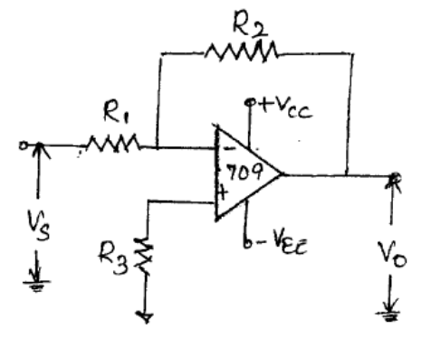  Fig.7(b) | CO3 | (10)
8. | a) | Mention and explain any two precautions that should be taken for operational amplifier circuit stability. | CO3 | (04)
 | b) | Design an inverting Schmitt trigger with V_{UT} = 3V and V_{LT} = -3V. Use 741 op-amp with a supply voltage of + 15V. Draw the circuit with component values mentioned on it. Also draw the input, output waveforms and hysteresis curve for the circuit designed. | CO2 | (10)
 | c) | Define gain bandwidth product, and discuss its application to inverting and non-inverting amplifiers. | CO3 | (06)
 |  | UNIT- V
9. | a) | With a neat sketch, waveforms and frequency response curve, explain the working of a differentiator. Derive an expression for its output voltage. Also mention the steps required to design the differentiator. | CO2 | (12)
 | b) | Design an astable multivibrator using 555 timer for a free running frequency f_{o}=1.45KHz, the positive pulse width tc = 0.421ms and negative pulse width td=0.269ms. Sketch the circuit with component values mentioned on it. | CO5 | (08)
10. | a) | Explain the significance of wave shaping network and decoupling capacitor in a monostable multivibrator. | CO5 | (04)
 | b) | In the DAC using current to voltage converter V_{ref}=2V, R₁=4.7kohms (resistance between pin no.14 of MC1408 DAC IC to V_{ref}) and R_{F}=10Kohms (feedback resistor of current to voltage converter). Assuming that the op-amp is initially nulled, determine the range for the output voltage V_{o}. Also draw the circuit diagram. | CO4 | (08)
 | c) | Design an adjustable voltage regulator, to satisfy the following specifications:  Output voltage V₀ = 3 to 8 V; output current I₀=0.5A. Voltage regulator to be used is LM317. Draw the circuit with component values mentioned on it. | CO5 | (08)

****************

